 | Job Description |  |  |  | Job Reference
Job Title | Education Officer/Vulnerable Children’s Worker
Service | Children’s Services | Team |  | Education Welfare Service
Location | Where the EWS are located
Reports to | Principal Education Welfare Officer
Grade: | Type of position: |  | Hours per Week:
Grade 7 | Full time – term time only + 1 week. |  | 37 hours for 39 weeks of the year
This job description has been designed to indicate the general nature and level of work performed by employees within this post. It is not designed to contain or be interpreted as an inventory of all duties, responsibilities and outputs required of employees assigned to the role.

Purpose
Education is a human right. The Education Welfare Service aims to work closely with all schools and other agencies to promote the regular school attendance of all young people. To assist in resolving any difficulties which may lead to a young person not receiving efficient education and remove barriers to support pupil’s accessing appropriate provision. The Education Welfare Service also aims to ensure that the LA’s statutory responsibilities in relation to school attendance, child protection and exclusions are carried out to the highest possible standard.

General Description of the job
- To work in partnership with schools and other agencies to support and ensure young people have appropriate access to education.
- To work with the EHE community and ensure that education is full, effective and suitable for all pupils.
- To ensure good processes and procedures within the GRT/EHE and CME area of the service
- To undertakes proceedings on behalf of the Local Authority, in respect of parents who do not ensure their children's regular attendance at school.
- To undertakes issuing Penalty Notices for unauthorised absence on behalf of the Local Authority.
- Will make relevant assessments and actions plans in partnership with pupils, parent(s), school staff and other relevant parties, concerning attendance at school or alternative educational provision.
- Use of legal action will be considered as part of a planned intervention with families.
- Ensure accountability for cases taken to court and liaise with schools concerning such cases.
- Offer information to parents and pupils about rights and responsibilities concerning attendance and the legal process, during any intervention with a family.
- Work with schools, families and agencies to promote the inclusion of vulnerable pupils.
- Education Welfare Officers and Education Officers are accountable through the Principal Education Welfare Officer.

Organisation Chart
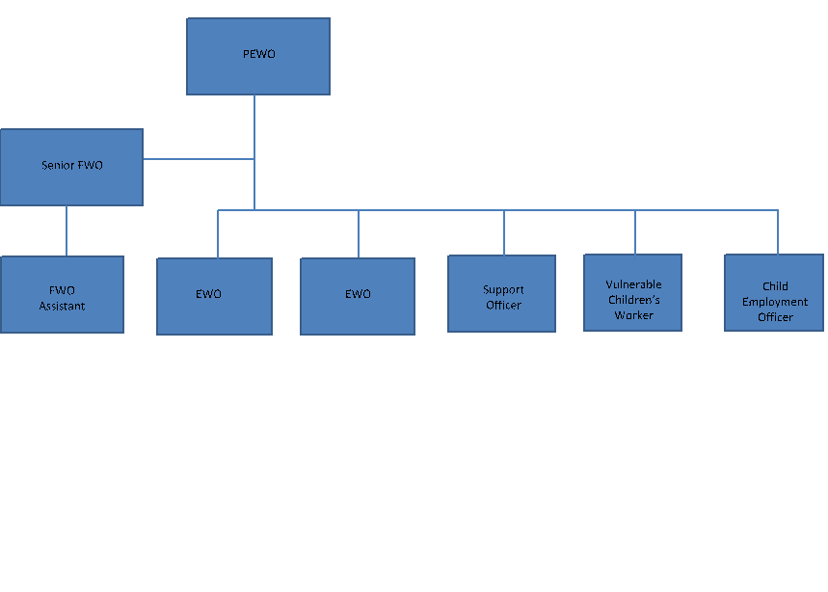

Main Accountabilities of the post
1 | Build relationships with the GRT/EHE community and improve education engagement for this community where necessary. Offer advice and guidance to families to support education engagement alongside promoting the importance of working with vulnerable pupils in a multi-agency setting
2 | Inclusion related casework. Working closely with the school, pupil, parent/carers and other relevant people in order to facilitate an improvement in an individual pupils’ school attendance
3 | Provision of support and advice to schools on Child Protection concerns and Education Welfare related matters (e.g. bullying, improving communication with parents, exclusions and school attendance)
4 | Meetings in school with parents/ carers and home visits when a pupil is GRT/EHE or CME to challenge and support
5 | Liaison with other professionals when pupil and parent/ cares require additional support
6 | Undertake proceedings on behalf of the Local Authority, in respect of parents who do not ensure their children's regular attendance at school for vulnerable groups
7 | Assist in training events to support schools with attendance/inclusion matters
8 | To report to the leadership team regularly
9 | To Undertake the LAs Statutory Duties in relation to Vulnerable groups of pupils
10 | To undertake any other reasonable duties which are commensurate with the grade of post and a degree of flexibility of post holder to perform work not specifically referred to above.

Additional Corporate Responsibilities
1 | High Support, High Challenge: To ensure that you bring forward their good ideas, to challenge areas where the Council can improve, and to contribute to the Council’s ongoing success
2 | Values Profile: To follow the principles set out in the Employees Values Profile
3 | Health and Safety: Take reasonable care for the health and safety of yourself and of other persons who may be affected by your acts or omissions at work; and co-operate with the Council to enable the Council to perform or comply with its duties under statutory health and safety provisions.
4 | Equal Opportunities: To take positive action to ensure a thorough understanding of and positive commitment to equality in both service delivery and employment practices.
5 | Safeguarding responsibilities: At all times to demonstrate and positively reinforce our commitment to safeguarding and promoting the welfare of children and vulnerable adults.

Scope
Resources |  | Facilities, equipment or systems within overall span of control
DBS Check required |  | Yes

Person Specification
Should focus here on describing the qualifications, skills, knowledge and experience an individual will require to successfully undertake the role. These should be split between essential and desirable. There is no need to repeat behaviour requirements.
Qualifications | Essential | Desirable
• Appropriate professional qualification (e.g. degree / teaching qualification/diploma in social work).  • 5 GCSE or equivalent (grade C or above).  • 2 A-Levels or equivalent. | E  E | D
Technical Skills. | Essential | Desirable
• Ability to build positive and appropriate relationships with young people.  • Strong interpersonal skills.  • Ability to communicate both orally and in writing with colleagues, children of all ages, parents and school staff.  • Organisational and time management skills.  • Ability to record work accurately and timely.  • Ability to analyse a range of situations and to work under pressure.  • Ability to work flexibly within the team.  • Ability to use information technology to support EWO work.  • Tact, diplomacy, confidentiality and sensitivity.  • Ability to use and respond to supervision  • Ability to relate sensitively to service users, particularly in terms of ethnicity and gender  • Ability to negotiate at all levels  • Personal resilience and emotional strength | E  E  E  E  E  E  E  E  E  E  E  E | D
Knowledge | Essential | Desirable
- Knowledge of Department for Education Advice and Guidance relating to school attendance and exclusions.  - Knowledge of the legal powers and duties governing school attendance and how they apply to local authorities, schools, pupils and parents. | E  E
Experience | Essential | Desirable
• Work with children, young people and families.  • Work within a team environment.  • Working autonomously and using informed initiative as appropriate  • Working with schools  - Writing formal reports for a variety of audiences | E  E  E  E | D
Special Factors | Essential | Desirable
Driving License and daily access to reliable vehicle | E

