Wokingham Borough

Digital and Technology Strategy

2022-2027

01 Foreword

02 Executive Summary

03 The Digital Vision

04 Changing The Way We Work

05 Digital and Technology Design Values

06 The Digital Position

07 Priorities and Objectives

Contents

Foreword

**Susan Parsonage**

**Chief Executive**

As Wokingham sits in the M4 corridor, it is commonly referred to as the UK’s “Silicone Valley”.

The Borough is home to the UK Headquarters of several multi-national companies and the community has a high rate of digital capability.

The digital expectations from the local community are naturally high due to Berkshire’s proximity to London, the growing technology sector presence and increasing technology awareness locally & nationally.

However, it is important to acknowledge that there is a level of digital poverty and exclusion across Wokingham that needs to be understood and addressed. This will allow us to ensure that our residents are better supported to be able to engage with the Council and their wider community in the way that best suits their needs.

**Our digital strategy aims to:**

The Council ambition is to support a digital led approach to service delivery, balanced with a clear need to address digital exclusion alongside the development of innovative and insightful ways to improve community cohesion through better use of technology.

By introducing digital technology that is intuitive, customer centric and focused on user experience, the outcome of enhanced digital adoption and channel shift will be driven through choice and driven by the needs our community.

Executive Summary

This strategy sets out the council’s digital and technology vision for the next 5 years. It outlines the digital and technology journey that will be taken to fulfil the digital ambitions.

Identifying key priorities and objectives that will aim to improve council service delivery and enhance the community digital experience, this strategy is built on robust technical foundations, a clear vision for continuous improvement and a dedicated approach to customer engagement.

The strategy sets out 5 strategic priority areas of focus that are fundamental to digital and technology improvement:

To ensure effective delivery of this strategy, a supporting action plan has been developed that will drive forward improvements and technology adoption. Reviewed annually, this action plan will be the mechanism for ensuring agility and emerging digital solutions are incorporated into service delivery plans.

This strategy should be read in conjunction with the council’s corporate plan, and its aims to improve customer experience.

There are a number of other key Council strategies that this strategy will support and enable. This includes but is not exclusive to:

Corporate Delivery Plan



**Digital and Technology Strategy**

**Customer Experience Strategy**

**Procurement Strategy**

**Anti-poverty Strategy**

**Equalities Strategy**

**Climate Emergency Strategy**

**People Strategy**

**Data and Insight Strategy (Emerging)**



The Digital Vision

Changing The Way We Work

By aspiring to be a smarter and more efficient organisation, this means there is a need to develop effective and accessible digital and technology services; making it easier for our customers, residents and businesses to work and communicate with us.

Using data to develop a better understanding of our communities’ needs and demands, whilst being a cornerstone of the development of a data-led decision-making culture.

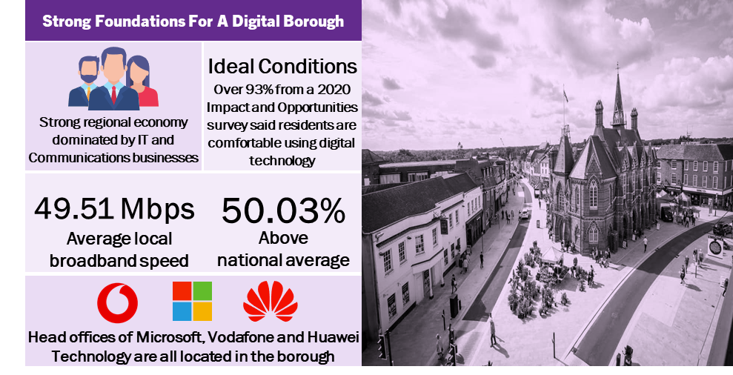**Our Borough’s Digital Characteristics**

Digital and Technology Design Values

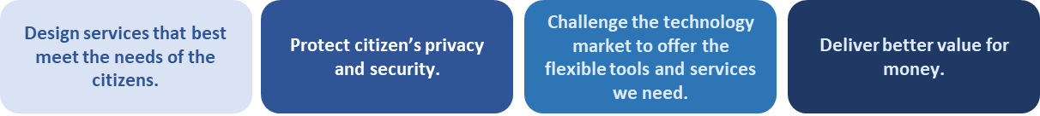

The Local Digital Declaration affirms the collective ambition for local public services in the internet age, and the commitment to realising it. It commits the Council and wider public sector bodies to working on a new scale, to:

This joint endeavor was initiated by the Department for Levelling Up, Housing and Communities, along with the Government Digital Service (GDS), and a collection of local authorities and sector bodies from across the UK.

Wokingham Borough, as an early adopter of this declaration, can work in collaboration on delivering and supporting the development of digital services which can directly improve services for the community.

We have used the best practice design values from this declaration to develop internal design values to support the delivery of this strategy. These values will inform all technical decisions made to ensure that the organisation is provided with secure, reliable digital and technology services. These design value are:

**How Our Digital and Technology Is Currently Used**

**Key Statistics**

Strong technology strides and investment have been made, which are a firm foundation to build upon. However, there are challenges and opportunities that need to be overcome to ensure the Council fully achieves its digital ambitions, these can be summarised as:

Priorities and Objectives

|  |  |  |
| --- | --- | --- |
| **Area** | **Challenge** | **Resolution** |
| Presentation with pie chart with solid fill**Data** | Some of our key systems currently do not current communicate with each other where there would be benefit. This results in a restricted view to the overall picture of how residents, businesses and the community interact with us. This also impacts our ability to measure our performance across the Council holistically. | Ensuring that future solution design takes into account systems communicating with each other where required. This will lead to a more complete picture of how the council is operating using data to measure performance in key areas of priority and to inform decision making. |
| Rating 3 Star with solid fill**Customer** | Lacking in a single view of how our customers interact with us. | Develop a master data management approach focused on key areas of customer interaction. |
| Network with solid fill**Efficiency** | 100+ line of business systems, leading to duplication of functionality. | Application rationalisation approach to ensure core product sets are exploited to meet the needs of the workforce and community. |
| Full Brick Wall with solid fill**Resilience** | The evolution in ways of working and the emerging hybrid workforce model has been accelerated, consequently the reliance, level and quantity of delivery required from Digital and Technology services has increased significantly. | Further adoption of agile ways of technology development such as DevOps across the Technology services. Investment plans that ensure Digital services are robust and active supplier management. |
| Shield Tick with solid fill**Security** | The threat of security incidents such as cyber-attacks is increasing. The impact of becoming the victim of a security incident could result in financial and reputational harm to the Council. | Investment plans and technology expertise are in place to ensure the Council continues to be cognisant of emerging security risks.  This will be coupled with user education to remain as secure as possible during this cyber age. |
| **Digital Experience**  Ui Ux with solid fill | Current online digital services do not give a consistent user experience. Many of services are solutions provided by third party suppliers inevitably leading to a differing look and feel. | Development of a website improvement programme that will ensure Digital services are centred around the needs of the customer and their lived experience. |
| **Digital**  **Exclusion**  Wireless with solid fill | Segments of the community are unable to access online services, due to digital poverty, accessibility issues or a lack of digital skills, | Build on the Digital Inclusion programme to ensure that Digital education and device plans are created. We will also prioritise accessibility standards in Digital service design to make sure they are usable for all our customers. |

To address the challenges identified, five key priorities with objectives have been identified, the achievements of these objectives will be supported by an action plan that is reviewed annually.

**The following priorities are not in order of importance.**

|  |  |  |
| --- | --- | --- |
| **Priority 1** | **Harness the opportunity to become a truly data driven organisation which embeds data and research across all services to fully understand resident need and performance insights.** | |
| **Objective 1** | Data will be accessible and aggregated from all our key systems to increase our view of the customer. This will make sure that we make data led decisions, leading to better outcomes for customers that consume Council services. |

|  |  |  |
| --- | --- | --- |
| **Priority 2** | **Drive efficiency and effectiveness of digital and technology services through robust supplier management, value for money procurement & demand management.** | |
| **Objective 1** | The technology services that the Council rely on will be demand led, ensuring that resources are focused and deployed where there is the greatest operational benefit. Through demand management it will ensure technical service are able to continue to support the organisation’s strategic priorities and change activity. |
| **Objective 2** | The environmental impact of IT will be part of our digital and technology decision making. This will help enable the positive contribution to the Councils climate change targets. |

|  |  |  |
| --- | --- | --- |
| **Priority 3** | **Ensure digital enablers are at the forefront of improving services and underpin delivery of the councils corporate priorities and strategies.** | |
| **Objective 1** | The Council will have a digital enabled workforce. Location will not be a barrier to the consumption of the Councils systems and technology. This will mean that the workforce can deliver services across the borough regardless of location. |
| **Objective 2** | Technology will be at the heart of Service change activity, ensuring a digital led approach to improvement and innovation. |

|  |  |  |
| --- | --- | --- |
| **Priority 5** | **Develop customer centric digital services that are innovative in design, intuitive and effective.** | |
| **Objective 1** | Digital services will be developed with user experience and accessibility at the centre of design. This will ensure a consistent digital offering that will enable service delivery, allowing those consuming Council services to access them in a way that is easy to use & convenient. |

|  |  |  |
| --- | --- | --- |
| **Priority 4** | **Continue to develop secure technical environments for our systems, data & digital services.** | |
| **Objective 1** | Cyber Security will be at the heart of systems and technology planning and delivery. This will ensure data is safeguarded for the workforce & community, with partners adhering to the same standards. |