WBCIR:16063

I would be most grateful if you could provide the following information in respect of providers of exempt accommodation (regardless of whether they are registered as providers of social housing with the HCA) covering the period of the last 3 financial years (i.e. 2019-20, 2020-21, 2021-221.

1. Details of the lowest awarded eligible core rent;
See table below

2. Details of the highest awarded eligible core rent;
See table below

3. Details of the lowest awarded gross eligible rent (i.e. inclusive of the core rent and the eligible service charges);
See table below

4. Details of the highest awarded gross eligible rent (i.e. inclusive of the core rent and the eligible service charges);
See table below

£ per week | 2019/20 | 2020/21 | 2021/22
Lowest core rent | 50.44 | 51.80 | 52.58
Highest core rent | 250 | 345.17 | 356.56
Lowest gross eligible rent | 71.16 | 65.41 | 106.75
Highest gross eligible rent | 423.98 | 435.42 | 435.42

5. Details of any core rents and gross eligible rents where the claimed amount is higher than the highest awarded amounts AND has been or currently is subject to an appeal to the first-tier tribunal social entitlement chamber.
None

6. Please confirm the names of exempt accommodation providers in your borough. Please name the providers/landlords who currently hold exempt accommodation status in respect of any of their residents and those who have been rejected exempt accommodation status.
The ‘title’ of supported and exempt accommodation relates to a claim for Housing Benefit as a whole, not the property or Landlord.

The list of providers below, are those who currently have tenants who have a claim with us that meet the criteria to be assessed as supported and exempt accommodation
- A2 Dominion
- Ability Housing Association
- Advance Housing & Support Ltd
- B.W.A
- Dimensions UK Ltd
- Encircle Housing Association
- Finefair Housing Association
- Hope and Vision
- Home Group
- Housing Solutions
- Loddon Homes
- London & Quadrant Housing Trust
- Norwood
- Radian
- Sovereign
- Space Supported Housing Ltd
- Transform Housing & Support Ltd
- Yeldall

Additionally, can you also provide:
7. A list of all Providers that have been approved on your framework to provide supported living or domiciliary care services in your borough.
This is available on our public contract register, available from our website
8. A senior level organisational chart displaying senior staff position/ department and relationship and, if available, contact information.
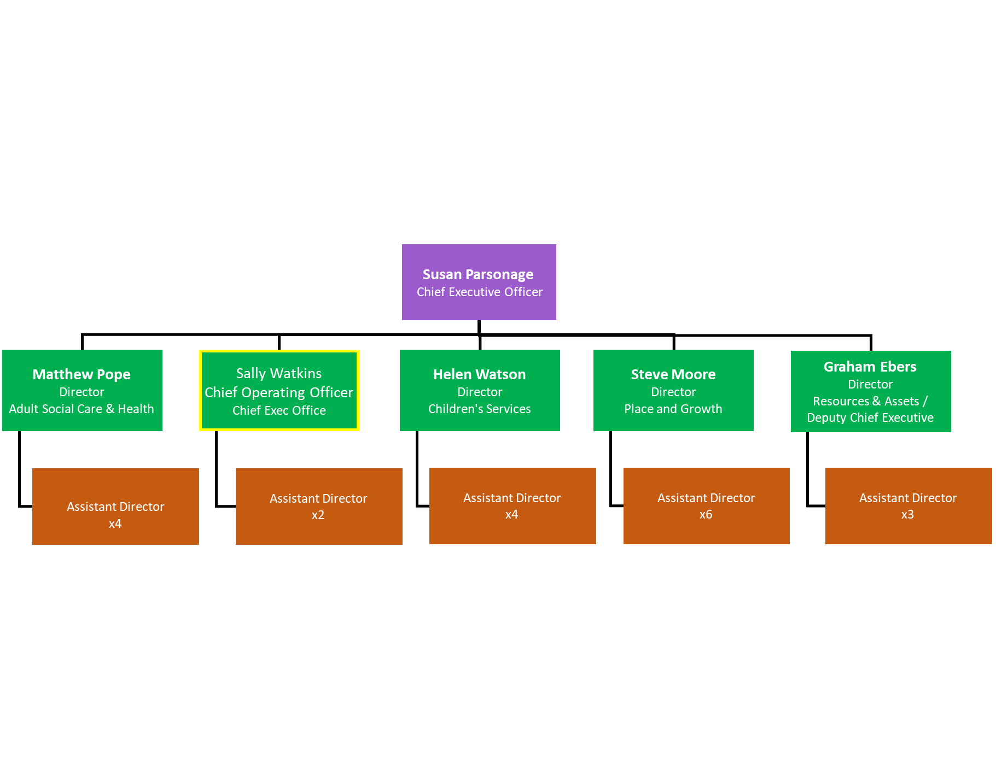
9. The latest Market Position Statement for Adult Social Care Services in your borough
https://www.wokingham.gov.uk/council-and-meetings/open-data/plans-policies-and-strategies/?assetdet91f252ff-550d-4cfa-a838-92ef2cb5f83c=631397&categoryesctl91f252ff-550d-4cfa-a838-92ef2cb5f83c=10598

