WBCIR:17042
Could I please raise a FOIA please as it is not clear whether this is a new mast or not. There is another mast some yards away from this huge one at the end of Holt Lane, which does not have an objection notice on it. It is therefore unclear what has happened regarding these masts. I never noticed either mast on the Reading Road opposite the Parish Rooms of St Pauls.
1. Can you please clarify when these masts were actually erected? Considering they are so close to the Holt School and residential area, (new housing has just been built next to the Church), the proximity of these masts are a worrying factor.
The permitted development rights are under the Electronic Communications Code.
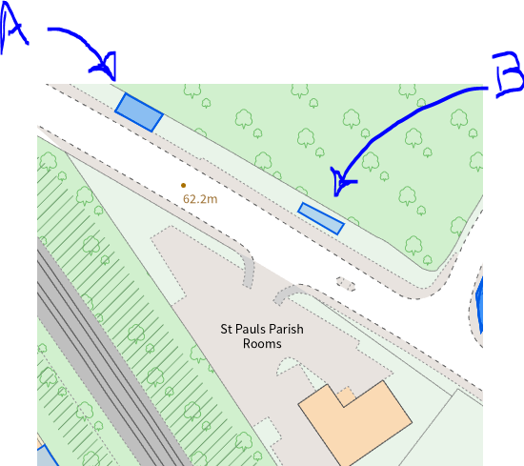
Records held in Planning relating to the Telecoms masts on Reading Road, opposite St Paul’s Parish Rooms
Site A:
- TL/2006/8693: Application approved 02 November 2006
  - Application for the proposed erection of 10 metre high monopole mast, 3 antennas within a GRP shroud, radio equipment housing and ancillary development.
- TL/2014/0444: Application approved 28 March 2014
  - Application for prior determination for the proposed erection of a replacement "jupiter" dual-stack type S monopole (15m to top of antenna shroud) with ancillary cabinets and meter pillar.
Site B:
- 163012: Application decided 13 December 2016
  - Prior notification application for the proposed installation of a 15m monopole supporting 3no. shrouded antennas and 2no. 300mm diameter dish antennas, 4no. equipment cabinets and development ancillary thereto including a meter cabinet.
- Permitted development notification: 18 February 2022
  - Removal and replacement of 1no equipment cabinet with associated ancillary works thereto including the installation of 1no GPS node.
- Permitted development notification: 21 June 2022
  - an equipment upgrade of an existing ground-based telecommunications site (upgrade of equipment on the existing tower) and associated works. Specifically, the works will involve the following:
    - the installation of a 17m high monopole with wraparound cabinet to replace the existing 15m high monopole.
    - removal of the Pogona cabinet and installation of a 1no Bowler cabinet, 1no RBS6130 and 1no MK5 Link AC cabinet.

