**WBCIR:17635**

**I am writing under the Freedom of Information Act to request the following information:**

**1. How many children have received SEND home to school transport every year since 2018/19 including the present year 2023/24 (please break down by year)**

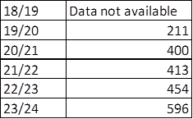

**2. What was your annual total spend on SEND home to school transport every year since 2018/19 (please break down by year). Please also provide your forecast spend for 2023/24.**

|  |  |  |  |  |  |
| --- | --- | --- | --- | --- | --- |
| **2018/19 Outturn** | **2019/20 Outturn** | **2020/21 Outturn** | **2021/22 Outturn** | **2022/23 Outturn** | **2023/24 Forecast** |
| **1,798,128.23** | **2,056,321.50** | **2,583,676.60** | **3,052,218.15** | **4,329,688.56** | **6,168,414.00** |

**3. How much is the single most expensive daily SEND home to school transport round trip journey you are currently funding?**

£384.00

**4. How far is the single most expensive daily SEND home to school transport round trip journey you are currently funding?**

45.4 miles