 | Job Description |  |  |  | Job Reference
 |  |  |  |  | <Insert the post number from WISE>
Job Title | Head of Governance and Improvement Services
Service | Governance & Improvement Services | Team |  | n/a
Location | Shute End
Reports to | Chief Executive
Grade: | Type of position: |  | Hours per Week:
SM4 plus Market Supp. | Permanent, Full Time |  | 37
This job description has been designed to indicate the general nature and level of work performed by employees within this post. It is not designed to contain or be interpreted as an inventory of all duties, responsibilities and outputs required of employees assigned to the role.

Service Purpose
1 The provision of assurance of high standards of governance are in place across the Council
2 The delivery of an efficient and effective Internal Audit service, providing assurance to the Council
3 The delivery of efficient and effective Democratic Services, supporting the administration of the Council’s business, and supporting councillors
4 The provision of effective electoral services
5 The cross-cutting leadership of the Council’s Continuous Improvement programme, working with officers and members to effect change and improvement, ensuring effective programme and project management
6 The service includes discharge of the statutory functions of Monitoring Officer and Returning Officer

General Description of the job
The Head of service will show and share leadership across the organisation, promoting ‘horizontal’, cross-Council solutions to complex challenges. S/he will share collective accountability for the Council’s successes and for situations where lessons have to be learned to secure further improvement. Their leadership will be visible, vocal and high-impact

The primary focus of the job is the delivery of effective and efficient leadership of the Council’s Governance and Improvement Support services

Organisation Chart
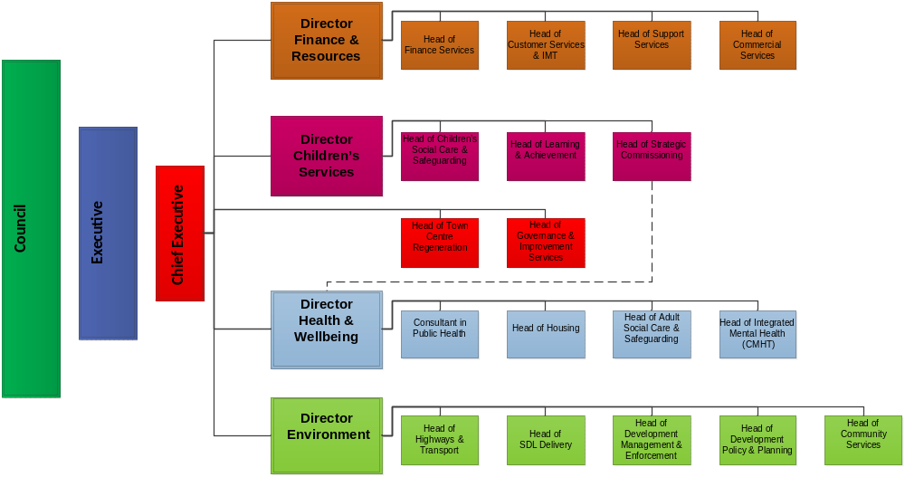

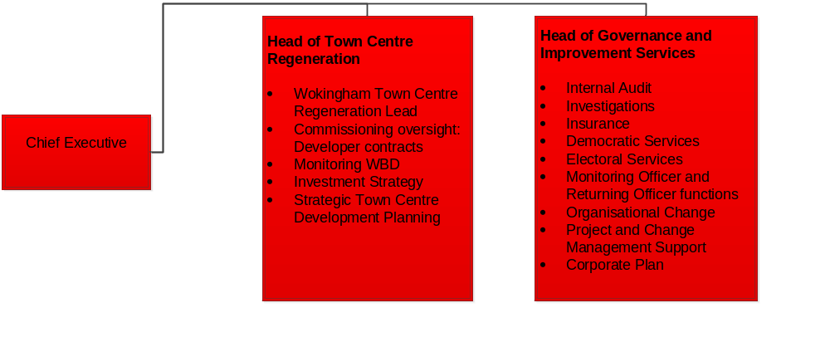

Main Service Accountabilities of the post
1 | To lead the delivery of efficient and effective services encompassed beneath the role, ensuring strong relationships with internal and external stakeholders are developed and maintained (including Town and parish Councils, other public bodies, central government etc)
2 | To ensure appropriate systems are in place for risk management, audit and assurance of the Council’s key financial and other systems
3 | To ensure effective support to councillors, and the delivery of effective and efficient Democratic Services, to enable proper discharge of the Council’s responsibilities
4 | To lead the programme of Continuous Improvement across the Council, strong links between Council departments, and between officers and members of the Council are in place and effective
5 | To coordinate and ensure effective programme and project governance and management arrangements are in place for all key workstreams
6 | To ensure an effective electoral system is operating
7 | To discharge the full range of designated accountabilities as the statutory Monitoring Officer and Returning Officer (see addendum).
8 | To lead the coordination and delivery of the Council’s business and corporate planning programme

Additional Corporate Responsibilities
1 | Professional Development: To ensure the continuous professional development of self, direct reports and all those in the service, through effective performance improvement, coaching, career planning and continuous professional development
2 | Collaborative Working: To drive cross-Council working for all staff, ensuring effective communication and collaboration across the organisation, to meet needs, opportunities and address challenges as they arise
3 | Customer Focused: To lead a customer-facing, proactive and responsive organisation, delivering to our residents and those who represent them. This requires leaders and managers to be flexible, adaptable and creative in order to meet the needs of our residents, and to lead active engagement with customers and communities
4 | Leading Change and Improvement: To lead change and improvement across the organisation, including developing adaptable managers and staff, and working within an adaptable and flexible structural and management environment
5 | Celebrating and Promoting: To ensure that positive messages about the achievements of service, and the Council are promoted and shared, internally and externally
6 | High Support, High Challenge: To ensure that, within the service and across the Council, staff are, and feel, empowered and to bring forward their good ideas, to challenge areas where the Council can improve, and to contribute to the Council’s ongoing success
7 | Member Engagement: To ensure effective involvement and engagement of the appropriate Lead Member and others as appropriate, to drive effective officer-member working for the benefit of residents
8 | Political Restrictions: This post is politically restricted under the provisions of the Local Government and Housing Act 1989. If you wish to receive further information about politically restricted posts please see the Wokingham Borough Website or contact the person named in the advertisement.
9 | Health and Safety: Take reasonable care for the health and safety of yourself and of other persons who may be affected by your acts or omissions at work; and co-operate with the Council to enable the Council to perform or comply with its duties under statutory health and safety provisions.
10 | Equal Opportunities: To take positive action to ensure a thorough understanding of and positive commitment to equality in both service delivery and employment practices.
11 | Special Factors: To work flexibly, including evenings and other out-of-hours requirements; willingness to travel; requirement to undertake such duties as are reasonably expected by the Chief Executive.  This is a ‘sensitive’ (i.e. politically restricted) post under the Local Government and Housing Act 1989, as amended by the Local Democracy, Economic Development and Construction Act 2009.

Scope
Staff |  | Number of employees within overall span of control | Approx. 32 FTE
Financial |  | Budget directly controlled (excluding salary costs) | Approx. £960,000
Resources |  | Facilities, equipment or systems within overall span of control | n/a
DBS Check required |  | No

Our Values and Competences

We have defined the values and competences that are important for those leading and managing in Wokingham Borough Council. Because these are important to us, they are reflected in the Job Description and in the Performance Improvement scheme for managers

One Team
• Demonstrates individual accountability and our collective responsibility: shares our success and our challenges; challenges when it is needed and supports all the time
• Always acts in the best interests of the Council and the communities the Council serves
• Takes a Council-wide and community view in decision making that acknowledges departmental, individual or group needs but weighs these against broader Council and wider community needs and priorities
• Demonstrates leadership within own service but in equal measure across the organisation
• Ensures that own service delivers the necessary support to achieve collective Council-wide priorities
• Models and demands effective communication vertically within department, horizontally across the organisation, and with members, Executive, Group and opposition; contributions and engagement are actively sought and valued
• Actively leads and engages with debate, discussion and decision making, demonstrating ‘high challenge, high support’ behaviour
• Actively contributes and takes a lead in Joint Board, Executive Briefing and other member forums as necessary
• Ensures that everyone in the organisation understands their role, their accountability, and their contribution to the Borough’s success
• Demonstrates support and challenge to members, colleagues and partners

Value & Pride
• Shows pride to work for the Council, to improve outcomes for the Borough and its residents
• Sets the tone across the organisation, in terms of pride, confidence in the Council’s work, openness to challenge and in demonstrating the value we afford to our staff for the work they do
• Invests in our staff, and demonstrates and engenders value in them, and encourages them to innovate, to use initiative and professional skill and judgement, and to feel pride in the Council as employer and service provider
• Demonstrates creative leadership as well as effective management in all of our activity
• Leads continuous improvement, challenges existing service and practice models, drives innovation to deliver better outcomes
• Holds and shares a clear focus on outcomes rather than inputs
• Leads in a way that enables learning from mistakes, so that the same mistakes are not repeated and we are constantly developing as we learn
• Takes care to ensure that everyone in the organisation understands their role and accountability, our collective priorities, and their contribution to the Borough’s success

Trust & Respect
• Drives the achievement of the Council’s Vision, and can see how what we individually do contributes to realising that vision
• Models respect, for each other, and for the different roles of elected member, management and staff in the day-to-day operation of the organisation
• Acts at all times with honesty and with integrity, and works collaboratively, recognising and celebrating the impact of diversity on the organisation, its customers and its workforce
• Demonstrates leadership in tackling difficult issues, holding courageous conversations and challenging the wrong behaviours when manifested by others
• Upholds the standards of conduct as reflected in the Council’s Code of Conduct and leads and acts ethically
• Shows respect for the sound professional advice of colleagues who have expertise, knowledge and experience: maximises the value and impact of the expertise and skill we share across the organisation
• Models, develops and encourages effective and open communication with staff across the organisation, with members and partners, and with the community, where respectful challenge is encouraged and helps us to learn and to improve
• Ensures that recommendations and decisions are clear, and based on evidence, and Fair Process
• Recognises the valuable part that everyone in the organisation has to play in delivering the excellence to which we aspire, and actively seeks their engagement

Customer Service Excellence
• Demonstrates at all times clear focus on improving services and outcomes for customers and communities
• Expects high levels of customer satisfaction
• Involves and engages customers and communities in developing, shaping and feeding back on services: engagement is early, and often
• Expects services to be responsive to customer and community need, and focuses our targeted services on those in greatest need
• Takes ownership of community issues and seeks to solve them
• Anticipates changing and likely future need, and organises and prepares to meet it
• Acts as an advocate for customers, communities and users of services when needed
• Drives and shapes services to ensure ease of customer access to advice, support and service

Leadership & Management

• Demonstrates strong, authoritative leadership, within service area and across the organisation
• Ensures active and rigorous performance management takes place across the services
• Ensures the Vision, Priorities and Principles are well-understood and are driving activity
• Leads with enthusiasm, passion and conviction
• Communicates clearly, articulately and compellingly
• Inspires loyalty, innovation and creativity
• Actively assesses, manages and reports risks
• Attends to the development and training needs of the service, ensuring professional growth and development, and new opportunities for staff, are features of the service
• Ensures reports have development plans and challenges to improve
• Uses own knowledge, experience and expertise to contribute to the training and development of the wider organisation
• Promotes and builds the Council’s reputation as a first class employer and service provider

Finance & Value for Money

• Delivers services efficiently as well as effectively
• Leads Council-wide drive for reduced costs and improving outcomes
• Actively manages finances within service area, knows and is able to account for all key financial areas and issues in service
• Participates actively in budget-setting and finding efficiencies
• Constantly seeks new and more efficient and effective service delivery models to achieve agreed outcomes
• Knows how services compare, with all relevant benchmark comparators, private, public, voluntary, in relation to cost, quality, VfM
• Actively appraises service delivery, opportunities for improvement, efficiency, new service models

Political Engagement

• Drives open and active communication with Executive Member
• Ensures a ‘no surprises’ culture across service area and with wider Executive
• Values and supports the work of elected members, and makes self available to meet, discuss, problem-solve with members
• Maintains a relationship of trust and respect with members
• Ensures officers area engaged proactively in communicating with members on key issues (individual, ward or Borough)
• Supports and enhances the skill and confidence of elected members in the stewardship of their portfolios
• Actively promotes communication across service area
• Holds members and officers to account if behaviours fall short of expected standards or of our values

Personal & Professional Development

• Takes responsibility for own development and learning
• Identifies development needs
• Understands the whole Council and how services work and are delivered to meet priorities
• Explores service delivery outside of the Borough to challenge and develop thinking and planning
• Accepts and uses coaching and mentoring when helpful
• Offers own skills as coach/mentor to others in the organisation as required
• Demonstrates awareness of own leadership styles, strengths and development areas, and has plan to support own learning and development

• Explores service delivery models outside of the Borough to challenge and develop thinking and planning

Person Specification
Qualifications | Essential | Desirable
Degree-level qualification | x
Professional qualification in appropriate discipline | x
Technical Skills. | Essential | Desirable
Negotiating skills | x
Financial management | x
People, Performance and Change management, coaching skills | x
Knowledge | Essential | Desirable
Professional understanding and knowledge of the Council’s key financial systems and legal compliance requirements, and the impact of Government policy and initiatives | x
Understanding of the external landscape, key partner organisations, integration of the national and local agendas | x
Experience | Essential | Desirable
Leadership to achieve successful outcomes in a complex organisation | x
Development of staff to support career progression, continuous professional development and staff engagement | x
Partnership working, stakeholder management, internal and external | x
Working in a political environment | x

Addendum – summary of Statutory responsibilities

Monitoring officer function

The Monitoring Officer is a statutory officer under s5 Local Government and Housing Act 1989 – the Council has a duty under s5(1) to designate one of their officers as a Monitoring Officer (MO). Under s5(2) it shall be the duty of the MO to report to the Council with regard to any maladministration or contravention of any enactment or rule of law, after consulting with the Head of Paid Service and the Chief Finance Officer. Such a report will have the effect of stopping the proposal or decision being implemented until the report has been considered.

The MO must ensure that the Council’s Constitution is up to date and widely available for reference by Members, staff and the public. Duties extend to providing advice to all Members on the scope of powers and authority to take decisions. She or he will also provide support and advice to Members and officers in their respective roles. This is to safeguard, as far as possible, Members and officers whilst acting in their official capacity from legal difficulties and/or criminal sanctions.

The Localism Act 2011 provides that a MO must establish and maintain a register of interests of all Members of Town, Parish and Borough Councillors. She or he must also secure that a copy is available for public inspection. The MO is empowered to grant dispensations to Members where their interest conflicts with fair decision making.

The MO conducts investigations on any allegations of breach of the Council’s Code of Conduct for Members and will make decisions on how to deal with such allegations, after consulting with an Independent Member and Chairman of the Standards Committee. She or he will also report to the Standards Committee.

It is vital that the MO keeps up to date with new and current legislation, and that she or he is respected by and visible to Members and senior officers. The MO must also maintain absolute confidentiality about matters connected with his or her role, if he or she is to have the trust and respect of Members and officers.

The Electoral Registration Officer (ERO)

The role of Electoral Registration Officer is a year-round task, the main duties of which include the creation and maintenance of the Register of Electors and similar tasks in relation to the Absent Voters List. The ERO is not responsible for the conduct of elections. The statutory involvement of the post is to provide Registers and Absent Voters List for each polling station as well as to candidates at the election and to the Returning Officer.

The Register of Electors is based on an annual canvass (audit) of all properties where electors reside and also the monthly rolling registration updates to the Register. The Register also includes the entitlement to vote at various types of elections.

The ERO will be responsible for the implementation of the new system of Individual Electoral Registration (IER), gaining support and co-operation from other officers and departments within the Council. The ERO reports to the Electoral Commission for performance standards and Cabinet Office for IER.

The Returning Officer (RO)

The Returning Officer is the person who has the overall responsibility for the conduct of elections. The RO is an officer of the Council who is appointed under the Representation of the People Act 1983. Although appointed by the Council the role of the RO is one of a personal nature and distinct and separate from their duties as an employee of the Council. The role of the RO is only relevant for the term of each particular election.

The RO is responsible for:-
• the nomination process for candidates and political parties;
• provision and notification of polling stations;
• appointment of presiding officers and polling clerks;
• appropriate administration and security of polling stations;
• preparation of all ballot papers;
• the actual Count and Declaration of Results;
• issue, receipt and counting of postal ballot papers;
• all candidates' election expenses return;
• presentation of final account and reclamation of funding from external body as prescribed.

The RO needs to have authority and influence within the organisation and needs to be known, respected and visible among officers and members. They need to be discreet and understand the importance of complete impartiality and fairness. The RO reports to the Electoral Commission for performance standards, reports to Regional Returning Officer for European elections, Police Area Returning Officer for Police and Crime Commissioner elections and to the Counting Officer (Electoral Commission post) for national referendums.

