WBCIR:18270

- A list of UK Shared Prosperity Fund (UKSPF) interventions to which you (the lead authority or partner local authority within your combined authority) have allocated funding, including the intervention code* and the value of the funding.
* Intervention codes provided in the UKSPF guidance from the Department for Levelling Up, Housing & Communities: https://www.gov.uk/government/publications/uk-shared-prosperity-fund-interventions-outputs-and-indicators/interventions-list-for-england

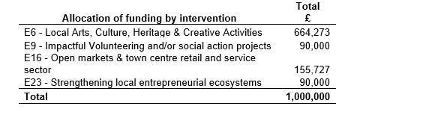

- The total amount of your UKSPF allocation that Central Government has transferred to you (the lead authority or partner local authority within your combined authority) by financial year.

