WBCIR:19426

1. How many pupils have started at schools run by the local authority so far in 2025?
The Council does not have this information readily available broken down by school. The data that can be provided is the number of mid-year applications that were received per year group, detailed below. Not all of these applications would have resulted in a child taking up any offer of a school place

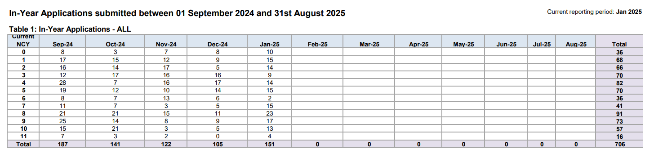

2. Of those, how many pupils moved from a fee-paying school? (including schools referred to as public, private or independent schools)
This information has only been recorded since September 2024 and it is not available broken down by school.

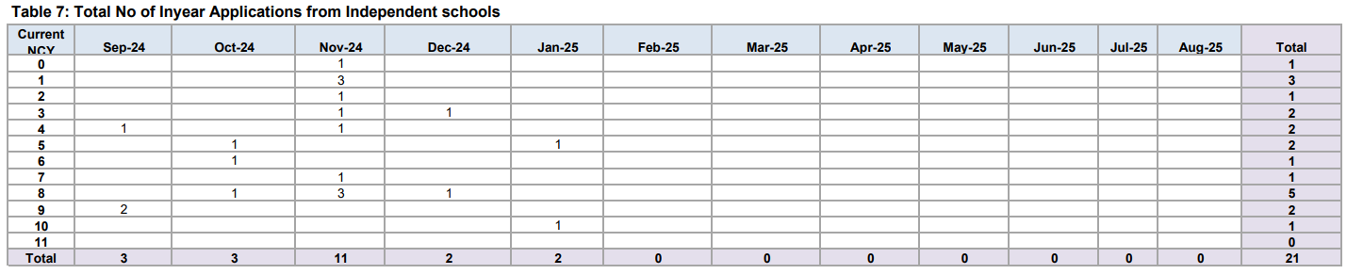

3. How many pupils started at local authority-run schools in 2024?
The Council does not have this information readily available broken down by school. The data that can be provided is the number of mid-year applications that were received per year group, detailed below. *Not all of these applications would have resulted in a child taking up any offer of a school place

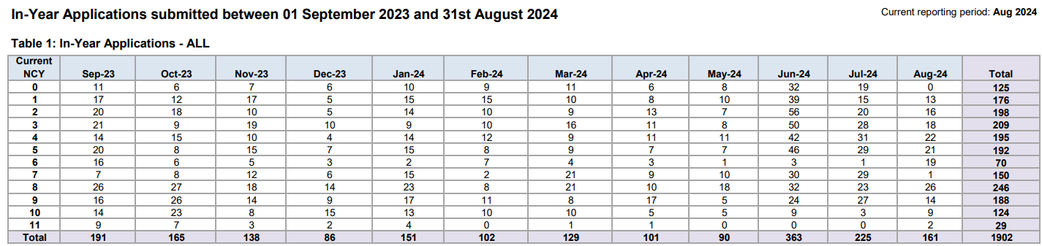

4. Of those, how many pupils moved from a fee-paying school?
Please refer to answer Q2 above

