WBCIR:19609
I am writing to request information under the Freedom of Information Act 2000. Specifically, I am requesting details on ALL spending with recruitment agencies, particularly spending that is not via your managed service provider.
1. What is the name of your agency recruitment provider aka an MSP (example Matrix, Comensura, Reed)?
Wokingham Borough Council have a corporate contract in place with Matrix for the supply of Temporary Agency Workers.
2. What was the total spend via that MSP provider from 1/1/2024 to 1/1/2025?
Matrix data confirms that our total spend on Temporary Agency Workers through the contract between 01 Jan 2024 to 31 December 2024 was £13,242,733
3. What was the spend on ‘off contract’ Agency Workers/Consultants/Interims that were not supplied by the MSP from 1/1/2024 to 1/1/2025?
£1,244,250.45
4. Please provide (preferably on excel) the spend, suppliers name, department, and most importantly the job title of that ‘off contract’ worker spend (as stipulated in point 3)
We do not report on Job Title. This would mean manually looking at each individual invoice to see if this data is stated. Our finance support officer carried out a spot check and only a few include this data. To collate this information it would take around 19 hours to answer.
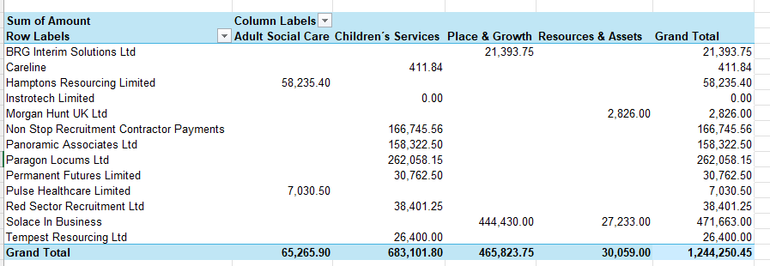
5. What was the spend on recruitment agencies used for permanent recruitment, agencies name, spend and department
No agency used between 01.01.24-31.01.25 for perm or fixed term recruitment

