
GARDEN BONFIRES/FIRE PITS/BBQ’S

What’s Wrong with Bonfires?

Burning garden waste may be a convenient way to get rid of bulky and messy waste; but what happens to it when you burn it? The process of burning it causes it to disintegrate and undergo chemical changes. The result is smoke. Smoke contains many unpleasant and harmful components, including carbon monoxide, dioxins, and particles, which are lifted into the air by the heat from the fire. But that’s not the end of it. Put simply, what goes up must come down. Depending on the atmospheric conditions, smoke may be dispersed over a wide area, causing no visible effects. Alternatively, the combination of careless burning and adverse weather conditions may mean the effects are felt more locally.
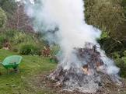

Health effects

Some of the chemicals emitted by bonfires can have serious health effects. It is unlikely that exposure to bonfire smoke will happen over a long enough period to cause serious harm to individuals, but it may be sufficient to cause temporary distress and acute illness in people who suffer from asthma, bronchitis or other respiratory disorders or heart conditions.

Air Pollution

The materials released into the atmosphere by a garden bonfire will damage the quality of the air. The effects may be transient and harmless most of the time, however, it there are several people with the same idea in the same area at the same time, or the material being burned is damp, and allowed to smoulder or contains plastics, rubber or painted material, then the resulting smoke will contain many more dangerous chemicals and the pollution will be much worse.

Nuisance and Annoyance

The localised pollution from garden bonfires can prevent other people from opening their windows, hanging out their washing and generally enjoying their gardens.

Safety

Fire from garden bonfires can quickly spread in dry conditions. Sheds, fences and other structures may be at risk. Don’t forget also that stray sparks carried off with the smoke can have a devastating effect on thatched buildings, dry crop fields and other grass areas.
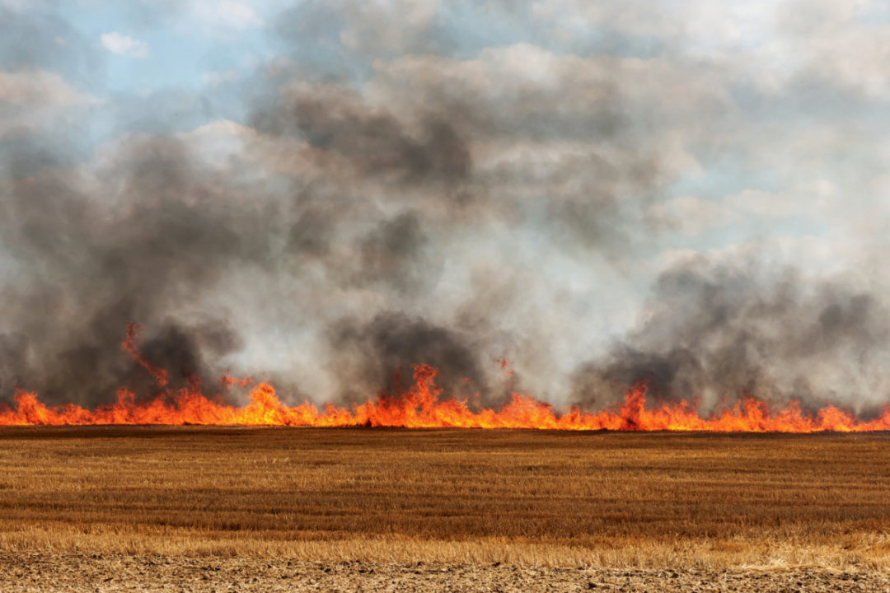

Can I Have a Bonfire?

It is a common misconception that local by-laws exist to control bonfires. They do not. There are no local by-laws or regulations affecting your right to have a bonfire. It is not illegal to have a domestic bonfire for the purpose of disposing of your own garden waste. The controls provided by the law are contained in the Environmental Protection Act 1990, which provides a means by which the Council can take action against people whose bonfires cause unreasonable interference with other people’s use and enjoyment of their gardens or pose a threat to the wider public health. In general, the Council discourages garden bonfires as a means of disposing of garden waste, especially in urban areas, and encourages the use of alternative methods of disposal for garden waste.

What Can I do with Garden Waste?

Wokingham Council offer a garden waste collection service, details of this service can be found at: https://www.wokingham.gov.uk/rubbish-and-recycling/garden-waste/order-garden-waste-collection/

Composting is one way of reusing your garden waste. You may have to shred woody material first and garden shredders suitable for this purpose are readily available to buy or hire. (But be careful not to cause a noise nuisance).
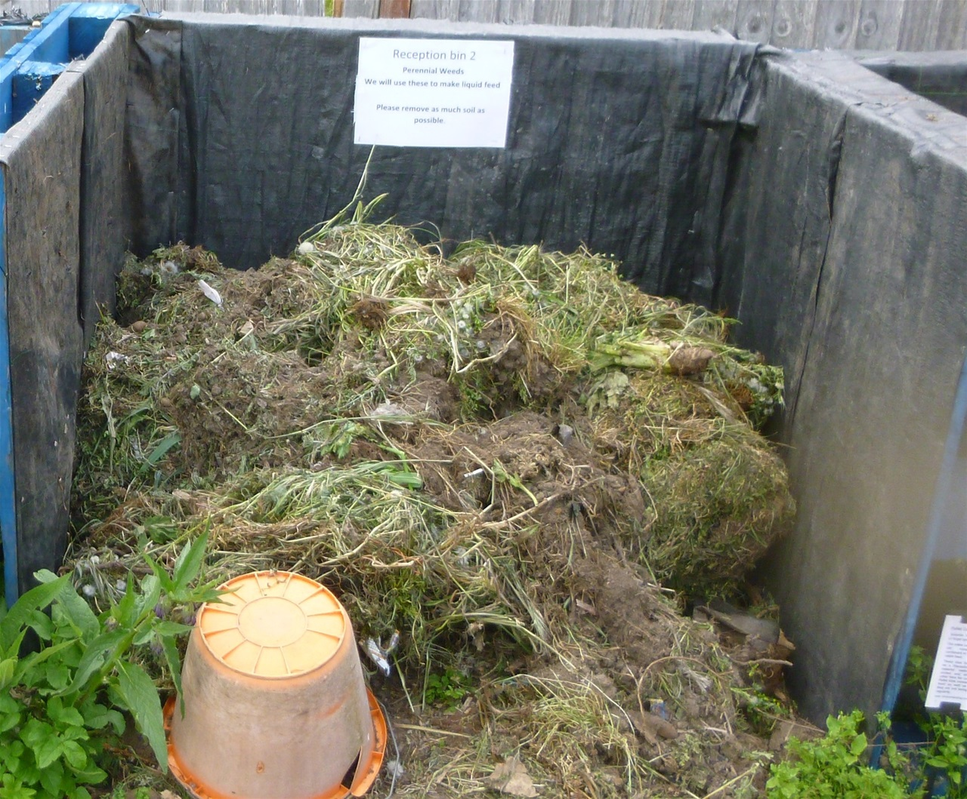

Want to Carry on Burning?

This leaflet has explained why garden bonfires can be undesirable and unnecessary. We recognise that sometimes there may be reasons why you decide you really do want to have a bonfire, in which case we ask is that you follow the simple precautions set out in this leaflet.

How does the Council Deal with Reports of Nuisance Bonfires?

If you have regular garden bonfires and the Council receives complaints about nuisance, we will try to resolve the problem using informal means. However, if the complaints continue, formal actions may be taken to abate the nuisance using the powers available under the Environmental Protection Act 1990.

Simple Steps to avoid trouble:
There are some simple steps you can take to reduce the impact of your bonfire, or to avoid having one altogether:

- Compost garden waste or use an alternative disposal service for green waste.
- DO NOT burn any oily rags, rubber, plastics, damp garden waste or other materials that would create heavy smoke or toxic fumes.
- Never light a bonfire when your neighbours have washing drying or are out enjoying their gardens or have windows open.
- Advise your nearest neighbours before you light a bonfire so they can be prepared for any minor inconvenience that may arise.
- Choose the time of day and weather conditions that will cause the least inconvenience to neighbours.
- Never leave your fire to smoulder for long periods and do not allow a bonfire to continue burning beyond dusk.
- Burn material quickly in small quantities in a hot fire so the minimum amount of smoke is created.
- Choose your bonfire site carefully, well away from trees, fences and windows.
- Beware of attempting bonfires on very windy days as it can so easily get out of control.
- Have a hosepipe and buckets of water handy just in case.
- Never leave a fire unattended.

