WBCIR:20436
I would like to make a request under the Freedom of Information Act please. Please could you provide, for each of the past five complete financial years, and the first quarter of the current financial year:
1. The total number of affordable homes approved by the council in each year
The council monitors the total number of homes approved each year and the total number of home and affordable homes delivered each year.
2. A breakdown, for each year, of every development approved that included affordable homes and include: the name of the development or road in which it sits, the total number of housing units, the total number of affordable units, the tenure type of the affordable units i.e social rent, shared ownership
Each year the council publishes the Five-Year Housing land supply which contains:
- The site application number
- the name of the development or road in which it sits,
- the total number of housing units,
- the total number of affordable units,
the past five years have been attached to this response, each year we publish the report online, we replace it with the most recent year. 2025 is found here: 2025 5YHLSS. Final.pdf
The tenure type of the affordable units i.e social rent, shared ownership can be obtained by searching the site application number on the public facing planning portal. The Reserved Matters applications will contain a tenure breakdown of which units are social rent or shared ownership.
3. A list of approved developments in each year that did not provide the council's minimum requirement for affordable homes. Please provide the name or street location of the development, the total number of homes in that development, the total number of affordable homes and tenure type, the reason given for not meeting the affordable homes benchmark, and any alternative provided in lieu including the amounts of any cash contribution
0
4. What percentage of homes in a development the council says should be classified as affordable in its housing policy
Policy varies depending on the location of the site, type of land and number of homes being provided:
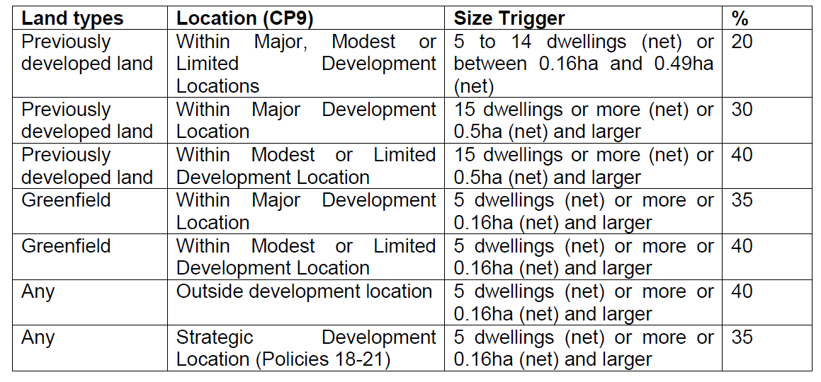
5. The amount of cash in each of those financial years that was paid by developers in lieu of providing affordable homes, and how much of that cash is yet to be spent
Affordable housing receipts and unspent below. The repayment clause is now mostly 10 or 15 years.
Year | Received | Unspent
2020/2021 | £6,858,318.51 | £274,192.00
2021/2022 | £25,286,175.25 | £20,184,524.75
2022/2023 | £10,826,290.53 | £5,862,553.73
2023/2024 | £8,594,130.90 | £8,594,130.90
2024/2025 | £2,989,556.99 | £2,989,556.99
2025/2026 | £0.00

0 for both temporary and emergency.
6. How much money from the pot of cash paid into by developers in lieu of providing affordable homes that was spent on emergency or temporary accommodation
0 Emergency Accommodation

