WBCIR:20978
1. Can you please provide me with the following:
a) the list of all SANG (Suitable Alternative Natural Greenspace) in Wokingham Borough
b) what the approved area of the SANG is
c) what is the agreed catchment area of the SANG (with respect to residential schemes of 10 or more dwellings as i recognise that proposals for less than this do not need to be within a specified distance of a SANG.
d) what area of each SANG has been assigned as part of the overall avoidance strategy for residential development
e) what is the remaining capacity in terms of area (hectares) of the SANG as part of the overall avoidance solution
Please find the table below which has all the info requested in points a) to e).
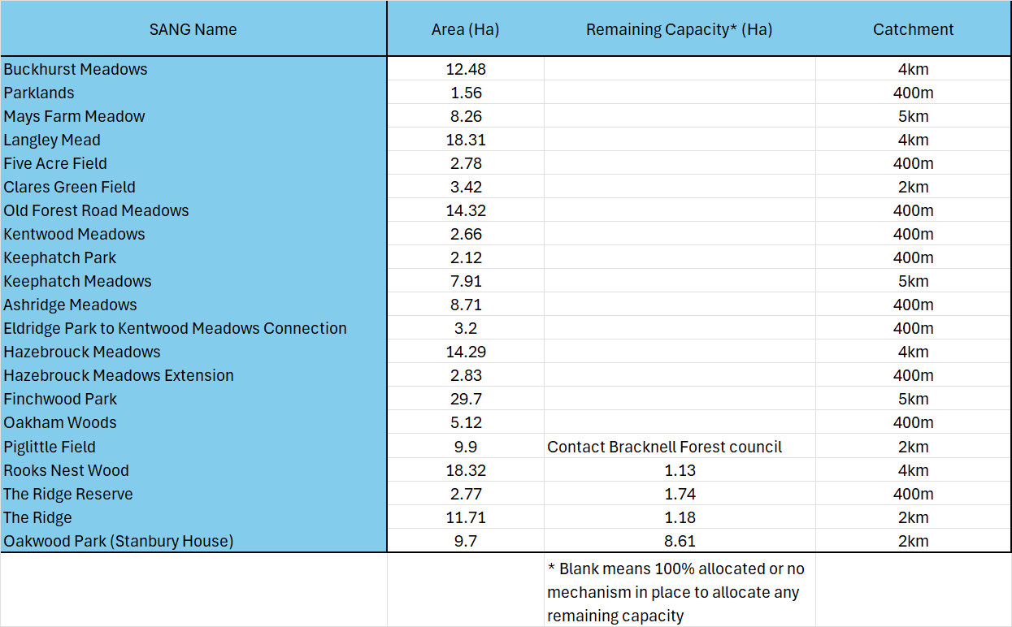
f) can you also confirm what the SANG requirements for residential development is depending upon whether the dwelling is within 5km of the Thames Basin Heaths Special Protection Area or lies in the 5-7km zone. I recognise that SANG requirements various according to the number of bedrooms. Can you response please confirm the current standards by distance and dwelling size? I recognise that the Council could also treat this request as one pursuant to the Environment Information Regulations given its subject matter.
The answer to f) is as follows, taken from the WBC policy page regarding SANGs:
"Proposed developments that are located within one of our four Strategic Development Locations (see the major developments page for more info) will have to provide new SANG at a minimum of 8ha per 1,000 new residents for any dwellings within 5km of the TBH SPA, or SANG between 1.73 - 2.16ha per 1,000 new residents for any dwellings between 5 - 7km from the TBH SPA.
Proposed developments outside of the SDLs that cannot provide SANG to the required standard as part of the development will need to make a payment contribution towards strategic SANG."
Further info can be found here: https://www.wokingham.gov.uk/planning-policy/advice-developers/thames-basin-heath-special-protection-area

