WBCIR:21116
Under the Freedom of Information Act 2000, I am requesting the following information regarding housing demand on your council waiting list as of December 2025 to January 2026.
1. Please can you provide me with how many people are waiting for a 2 bedroom property in band 1, and band 2.
Band 1: 16 applicants
Band 2: 30 applicants
2. Please can you also confirm the categories band 2 are broken down in to and how many people are within each category.
Categories – see Banding Scheme 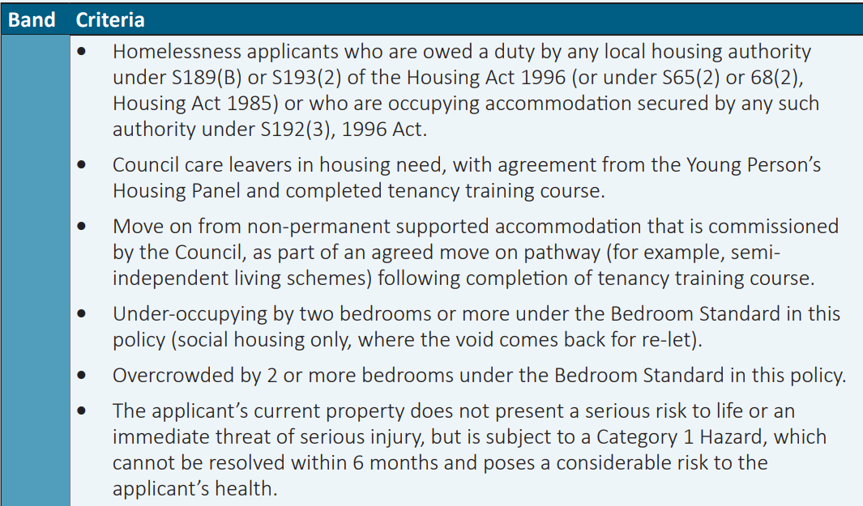
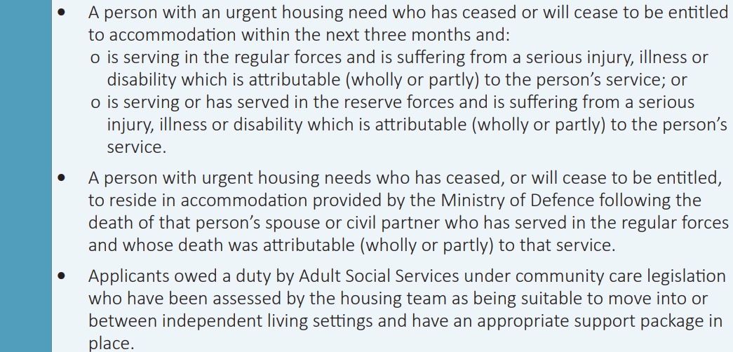
- 4 applicants due to overcrowding by 2 or more bedrooms
- 25 applicants under Relief Duty
- 1 applicant under-occupying by 2 or more bedroom

