WBCIR:21345
Freedom of Information request relating specifically to motorhomes. I am requesting the following information held by your constabulary for the periods:
• 1 January to 31 December 2025
• 1 January to 28 February 2026
Please provide a breakdown of the data for each council area or policing district within your constabulary’s jurisdiction, where applicable.
1. Motorhome-related road traffic collisions
The total number of recorded road traffic collisions involving motorhomes or motor caravans during each period, along with a breakdown by severity (fatal, serious injury, slight injury). Please also confirm the month in each period that recorded the highest number of motorhome-related collisions.
This is not a question that we can answer. Whilst we do collate personal injury accident data for submission to Thames Valley Police, motorhomes are not specifically categorised as such and therefore we cannot identify which category they would fall under. For reference, the list of vehicle types are as follows:
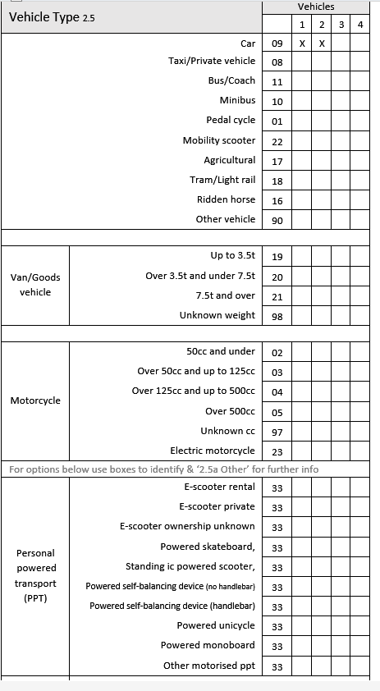
2. Causes of motorhome collisions
The leading recorded causes or contributory factors for collisions involving motorhomes during each period. Where available, please include causes such as driver error or inattention, speeding, poor weather conditions, vehicle defects or mechanical failure, and driver fatigue. Please also indicate the month in which the leading cause resulted in the highest number of motorhome-related collisions.
Please see answer to question 1
3. Seasonal trends
Monthly totals for motorhome-related collisions during each period, to identify any seasonal patterns.
Please see answer to question 1
4. Driver age groups
The number of motorhome-related collisions involving drivers in the following age groups during each period:
• Under 25 years old
• 25–64 years old
• 65 years old and over
Please see answer to question 1
5. Motorhome-related enforcement
Where vehicle type is recorded, the total number of enforcement actions involving motorhomes during each period, including where applicable:
• Speeding offences
• Vehicle defect or roadworthiness offences
• Weight or loading-related offences
• Insurance-related offences
The Council does not undertake enforcement action of the type mentioned or collate such data. I would suggest contacting Thames Valley Police directly to see if they hold any data.

