WBCIR:21364
I am writing to request information under the Environmental Information Regulations 2004 regarding the trees located on the grass verge adjacent to the road / highway land on the junction of Highgate Road and Campbell Road, Woodley (postcode RG5). Specifically please provide the following for the group of trees at this specific location:
1. Inspection history- Copies of the most recent inspection reports / records from the council's tree management system e.g. the 'Collector App' or similar.
WBC Operational Tree Management hold no inspection records for trees associated with the FOI request – the trees are rooted outside of the adopted public highway and therefore are categorised as private assets outside the direct control of Wokingham Borough Council.
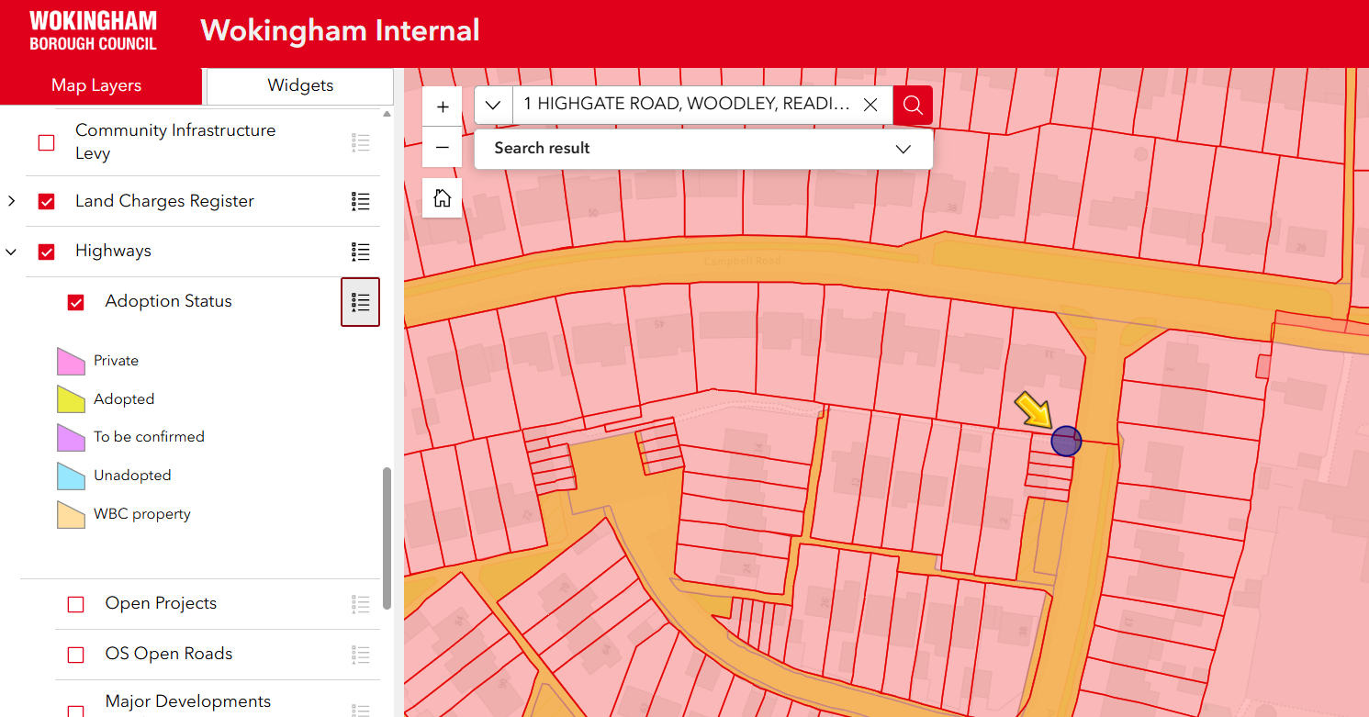
2. Date of last inspection- The date the last physical safety inspection was carried out by a qualified Aboriculturist, Tree Officer or external consultant.
WBC Operational Tree Management received a formal enquiry dated 18/02/2026 via the councils online reporting portal, with a full response issued 19/02/2026 09:07 confirming the tree is under private ownership. The enquiry was managed as a desk top study, given the supporting evidence confirmed private ownership. The private tree has not been inspected or added to the council’s tree asset system (Ezytreev).
3. Recommended works- Details of any remedial works or maintenance (e.g. pruning, crown lifting) identified in the last three years and whether these works have been completed.
N/A
4. Risk Category- The 'Risk Zone' or priority level assigned to these highway trees according to the Wokingham Borough Council Tree Inspection Framework.
N/A

