WBCIR:21630
Under the Freedom of Information Act 2000, please provide the following for every state-funded primary and secondary school in your local authority for National Offer Day 2025 and National Offer Day 2026:
1. The school name and DfE URN
School | DfE Number
Primary Schools
Alder Grove CofE | 2009
Aldryngton | 2116
All Saints | 3372
Bearwood | 2100
Beechwood | 2008
Crazies Hill CofE | 3048
Earley St Peter's | 3312
Emmbrook Infant | 2121
Evendons | 2002
Farley Hill | 2088
Finchampstead | 3315
Floreat Montague Park | 2003
Gorse Ride Infants' | 2232
Grazeley Parochial | 3319
Hatch Ride | 2163
Hawkedon | 2237
Highwood | 2246
Hillside | 2238
Keep Hatch | 2106
Lambs Lane | 2089
Loddon | 3371
Nine Mile Ride | 2067
Oakls Infant | 2132
Polehampton | 3046
Radstock | 2235
Rivermead | 2167
Robert Piggott CofE Infant | 3057
Saint Sebastians | 3330
Shinfield Infant | 2157
Sonning CofE | 3320
South Lake | 2247
St Cecilia's | 2010
St Dominic Savio Catholic | 3368
St Nicholas | 3037
St Teresa's Catholic Academy | 3341
The Colleton | 2149
The Coombes | 2006
The Hawthorns | 2227
The Piggott | 4505
Walter Infant | 2137
Wescott Infant | 2101
Wheatfield | 2001
Whiteknights | 2105
Willow Bank Infant | 2160
Windmill | 2000
Winnersh | 2146
Woodley CofE | 3056
Junior Schools
Emmbrook Junior School | 2130
Gorse Ride Junior School | 2148
Oaklands Junior School | 2062
Polehampton Church of England Junior | 3370
Robert Piggott CofE Junior School | 3061
Shinfield St Mary's CofE Junior Sch | 3041
St Paul's CofE Junior School | 3055
Westende Junior School | 2184
Willow Bank Junior School | 2161
Secondary Schools
Bohunt School Wokingham | 4001
Maiden Erlegh School | 4053
Oakbank | 4002
St Crispin's School | 4048
The Bulmershe School | 4051
The Emmbrook School | 4049
The Forest School | 4050
The Holt School | 4047
The Piggott School | 4505
Waingels | 4060
2. The number of offers made under the sibling criterion
Please see below links for answers to questions 2 – 6:
- Secondary school allocation information 2026_0.pdf for Q2,3,4,5 & 6
*where you see N/A this is because the schools is undersubscribed and as such we do not record the distance of the last child allocated a place.
- Primary school allocation statistics 2026.pdf
*where you see N/A this is because the schools is undersubscribed and as such we do not record the distance of the last child allocated a place.
3. The number of offers made under any distance or proximity criterion
Please see answer to question 2
4. The admission criterion under which the last successful applicant was offered a place (e.g. "Distance", "Sibling", "Faith")
Please see answer to question 2
5. Where distance was the deciding criterion for the last successful applicant: the home-to-school distance of that applicant (i.e. the furthest distance from which a place was offered under the distance criterion), the unit of measurement (miles, metres, or kilometres), and whether straight-line or walking distance was used
Please see answer to question 2
6. Whether the school was oversubscribed
Please see answer to question 2

7. The number of admission appeals heard for the 2025 intake year
Entry to Secondary - This year’s bulk appeals have not been heard yet, but we have received the following number of appeals for Holt and Maiden Erlegh. These are the only secondary schools that we manage appeals for so we do not have any appeals data for the other WBC secondary schools. 2025 data below
The Holt 4
Maiden Erlegh 10
Entry to Primary- It is too early in the 2026 E2P process for appeals data so we have included the 2025 round below:
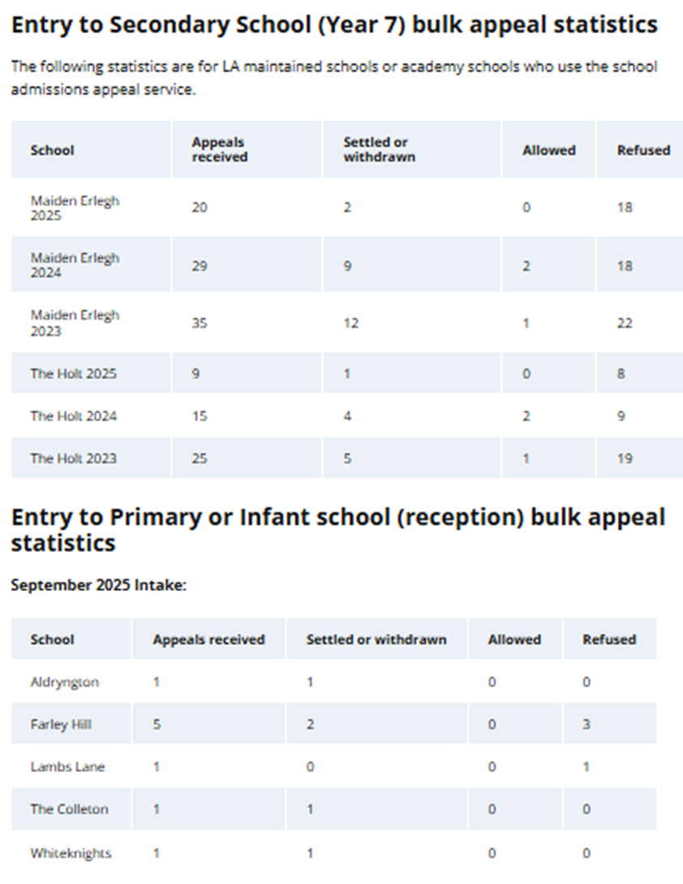
8. The number of those appeals that were upheld (place offered after appeal)
Please see answer to question 7

