WBCIR:21728
Under the Freedom of Information Act, please provide the following council-wide yearly data from Wokingham Borough Council for each of the following financial years (from the first to last day of each financial year) - 2021/22, 2022/23, 2023/24, 2024/25, and 2025/26:

Council tax:
1. The number of live council tax accounts at the end of each financial year (if held).
This information is not held by the Recovery Team. We track total number of accounts in arrears but do not split into live vs closed.

2. The number of council tax accounts with arrears at the end of each financial year.
2021 – 4,306
2022 – 4,208
2023 – 4,522
2024 – 4,766
2025 - 4,697

3. The total value (£) of council tax arrears outstanding at the end of each financial year.
We do not have this data back to 2021 but can report on outstanding debt per tax year at year end.
2021 – £758,494.75
2022 – £742,610.19
2023 – £1,186,428.34
2024 – £1,545,644.96
2025 - £2,023,729.65

Debt collection:
4. The total amount (£) of council tax arrears collected/recovered in each financial year (regardless of the year the debt relates to).
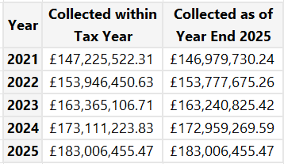
We cannot run a report on collected in year regardless of year but please see closest figures we can run.

5. The total number of liability orders issued for council tax arrears in each financial year.
2021 – 4397.
2022 – 4534.
2023 – 4290.
2024 – 3959.
2025 – 4320.

6. The total value (£) of liability order costs charged to council tax accounts in each financial year.
2021 – £329,635.09
2022 – £318,588.00
2023 – £403,637.18
2024 – £408,402.29
2025 - £402,276.00

7. The total number of council tax arrears cases referred to enforcement agents in each financial year.
This information is not held by the council however we have contacted our enforcement agents to check if they store this information which we will send over.

8. The total value (£) of unpaid council tax debt for cases referred to enforcement agents in each financial year (based on the balance recorded when the case was referred, where available).
This information is not held by the council however we have contacted our enforcement agents to check if they store this information which we will send over.

9. The total value (£) of enforcement agent fees added to council tax accounts in each financial year (if held).
This information is not held by the council however we have contacted our enforcement agents to check if they store this information which we will send over.

