WBCIR:21987
1. The number of households in council tax arrears for each financial year from 2015-16 to 2025-26.
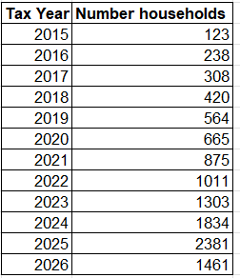
Please note that this report includes closed accounts. Therefore, the term ‘households’ would also include where they have moved home but still have a debt.

2. Of those households who are in council tax arrears please provide the average amount of arrears a household is in for each financial year from 2015-16 to 2025-26.
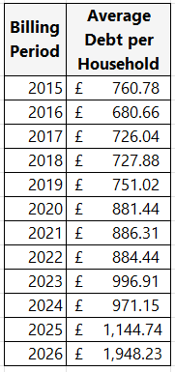
As with question one, this data includes closed accounts.

3. The total amount of council tax arrears for each financial year from 2015-16 to 2025-26.
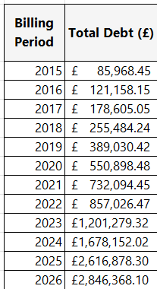
As with question one, this data includes closed accounts.

4. The highest amount owed by one household for 2025-26 for the most recent financial year.
The highest amount owed by one household for 2025/26 is £5936.72.

