WBCIR:22001
I would like to request information relating to any recent intranet, staff portal, digital workplace, or internal communications platform redesign or implementation carried out by your organisation.
Wokingham Borough Council is currently undertaking an intranet redevelopment project. The information we hold in scope of your request is set out below.

1. A copy of any project brief, business case, project initiation document, or project plan relating to the intranet/staff portal project.
Project documentation
The Council holds project documentation including project plan, business case and supporting materials relating to the intranet redevelopment. Relevant extracts have been provided in redacted form where appropriate. Some information has been withheld under Section 40 (personal data) and Section 43 (commercial interests).
Business case – extracts from relevant documents:
“A lot of information is out of date, meaning reduced productivity and frustration by users”
“Current user experience needs improving”
“Our Intranet has fallen into disrepair, which poses several risks… loss of content… staff unable to access key information”
“We must first build a functional Intranet… user-friendly structure… accurate and up-to-date information… secure and well-governed environment”

2. Any design documents, wireframes, user journey documents, information architecture diagrams, sitemap documents, or content structure documents created as part of the project.
Design documentation, screenshots / mock-ups
The Council holds prototype designs and intranet layout visuals. Representative sample screenshots and mock-ups have been provided in redacted form. Content relating to internal services, unpublished information and sensitive areas has been removed.
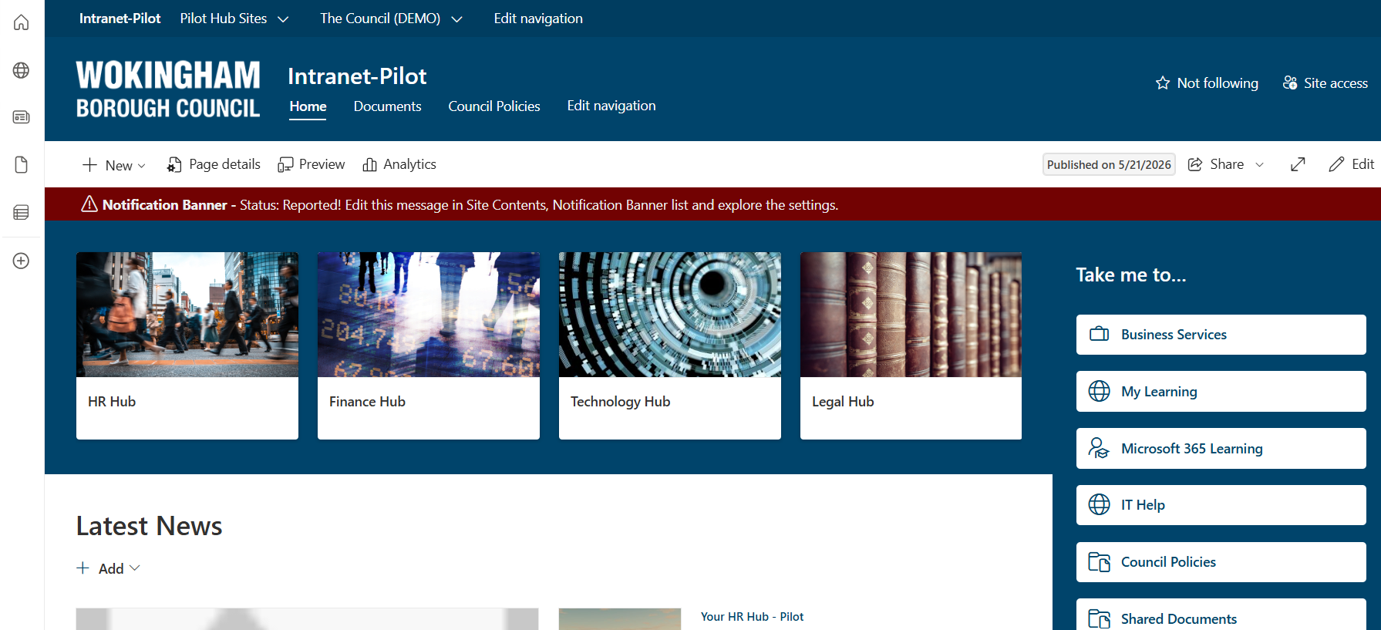
3. Screenshots, mock-ups, prototype images, or design visuals showing the intranet/staff portal layout, homepage, navigation, or key internal service pages.
Please see above

4. Any evaluation, lessons learned report, benefits realisation report, or post-implementation review produced after the project went live.
The project is currently in delivery and has not yet reached full implementation. No post-implementation review, lessons learned report or benefits realisation report is currently held.

5. The name of the platform or technology used, for example SharePoint, Viva Connections, Sitecore, Umbraco, Drupal, WordPress, GOSS, Invotra, or another system.
The intranet is being delivered using Microsoft SharePoint Online, with integration into Microsoft 365 services including Viva Connections.

6. The name of any external supplier, agency, consultancy, or implementation partner involved in the project.
The Council is working with Phoenix Software Limited as the external implementation partner supporting delivery of the intranet redevelopment.

7. The approximate project cost or budget, including supplier costs where available.
The Council holds information on the project budget and associated supplier costs. The overall project is being delivered within an approved budget in the region of £60,000.
Detailed cost breakdowns, including supplier day rates and pricing structures, have been withheld under Section 43 (commercial interests), as disclosure would be likely to prejudice the commercial position of both the Council and its suppliers.

8. The implementation date or go-live date.
The intranet is currently in development and is being delivered on a phased basis. A final go-live date has not yet been confirmed; however, initial releases are expected during 2026.

