WBCIR:22026
I am making a request under the Freedom of Information Act 2000 for the following information relating to supported and exempt accommodation in your area.
1. A list of providers (registered providers, charities, and any other organisations) that the council currently commissions, contracts with, or works with to deliver supported, specified, or exempt accommodation.
Service Provider:
Nest Care Homes
A2 Dominion Housing Group Ltd
The Poor's Land Charity

2. A list of providers currently in receipt of Housing Benefit payments from the council in respect of supported or exempt accommodation, for the most recent financial year for which data is held.
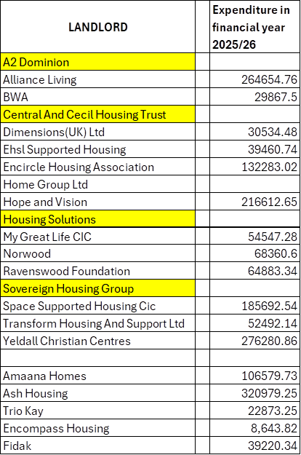
We have been advised by our Benefits department that the lines highlighted in yellow receive payments for other tenants and receive 1 lump sum payment which cannot breakdown in the timescale. (Section 12)

3. Where this information is held: the total Housing Benefit expenditure paid to each of those providers in that financial year.
Please see above table

4. Whether the council operates a framework, approved provider list, or accreditation scheme for supported or exempt accommodation. If so, please provide the name of the framework, the list of providers on it, and details of when it is next due to be tendered or refreshed.
Adult Social Care does not operate a separate framework, approved provider list, or accreditation scheme specifically for exempt accommodation. The Council’s Adult Social Care’s Care and Support Framework is used to commission the care and support element of supported living, including accommodation-based support. The housing or accommodation element is usually arranged separately from the care and support contract, for example through a landlord, registered provider, housing provider or accommodation partner.

5. The name and contact details of the team or officer responsible for commissioning supported and exempt accommodation.
Commissioning Manager for Working Aged Adults – Sally.Cunnison@Wokingham.gov.uk

