WBCIR:22218

Under the Freedom of Information Act 2000, I am requesting information regarding the council's environmental enforcement activities (specifically relating to Fixed Penalty Notices issued for offences such as littering, spitting, dog fouling, fly-tipping, and Public Spaces Protection Order breaches). Please provide the information for the last four financial years: 2022/23, 2023/24, 2024/25, and 2025/26 to date (or calendar years 2023–2026 if financial year data is unavailable).

1. Outsourcing & Contracts:
a) Does the council contract out its environmental enforcement service to a private third-party provider, or perform these duties in-house? In house
b) If outsourced, please state the name of the contractor(s) and the start and end date of the current contract in place.

2. FPN Volume: How many Fixed Penalty Notices (FPNs) have been issued in each of the requested years? Please provide a breakdown by offence category (e.g., littering, spitting, dog fouling, fly-tipping, PSPO breaches, etc.) Please see data sheet below

3. Revenue Generated: What is the total income/revenue (£) received by the council from environmental FPN payments in each of the requested years? Please provide figures split by category of offence if available.
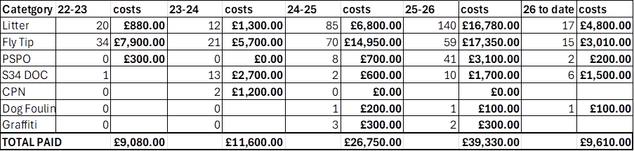

4. Representations and Appeals:
a) How many FPNs were formally disputed, appealed, or subject to written representations in each of the requested years (broken down by category of offence)?
b) Of those disputed/appealed, how many were:
i) Cancelled / Upheld in favour of the recipient (Successful)
ii) Rejected / Upheld in favour of the council (Unsuccessful)
iii) Currently pending an outcome?
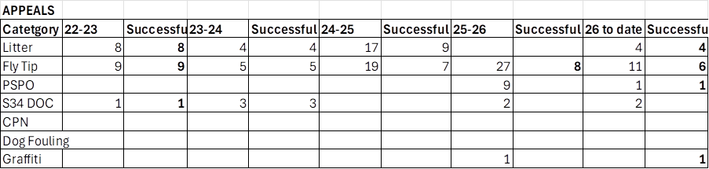

5. Prosecutions: How many individuals/entities have been prosecuted in the Magistrates' Court for non-payment of FPNs or direct environmental offences in each of the requested years (broken down by category of offence)?
0

